Mongo Database Assignment



SUBMITTED BY
Hifza Alvi
ROLL NO: 1250259026
Master’s of Computer Application (MCA DS&AI 1) BABU BANARASI DAS UNIVERSITY
Lucknow, Uttar Pradesh

UNDER THE GUIDANCE OF ANKIT SONI
(FACULTY , BBDU)

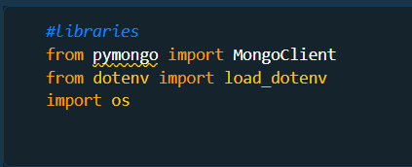
------Importing Library-------
--Loading Environment Variables & Connecting to MongoDB Atlas--
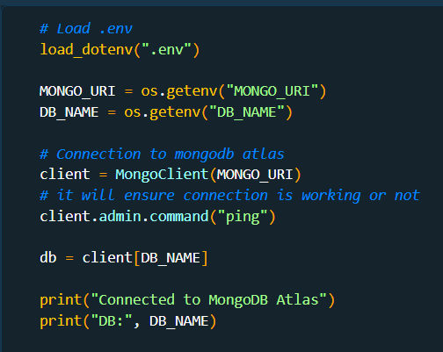

Output:- Connected to MongoDB Atlas DB: CollegeDB

-------Uploading data to atlas -------
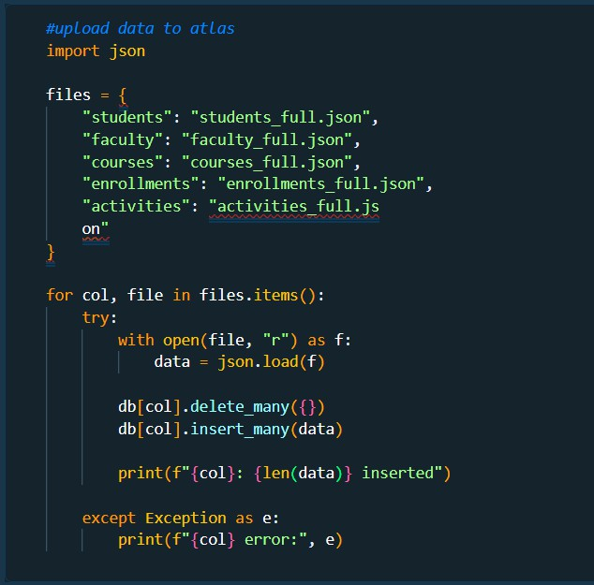
Output:-
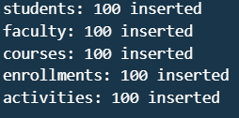

------Verifying data is loaded or not -------

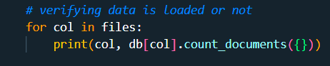
Output:-

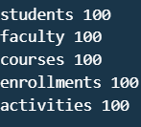

- Complex Filters & Projections
Q1. List the names and departments of students
who have more than 85% attendance and are skilled in both "MongoDB" and "Python".

QUERY-
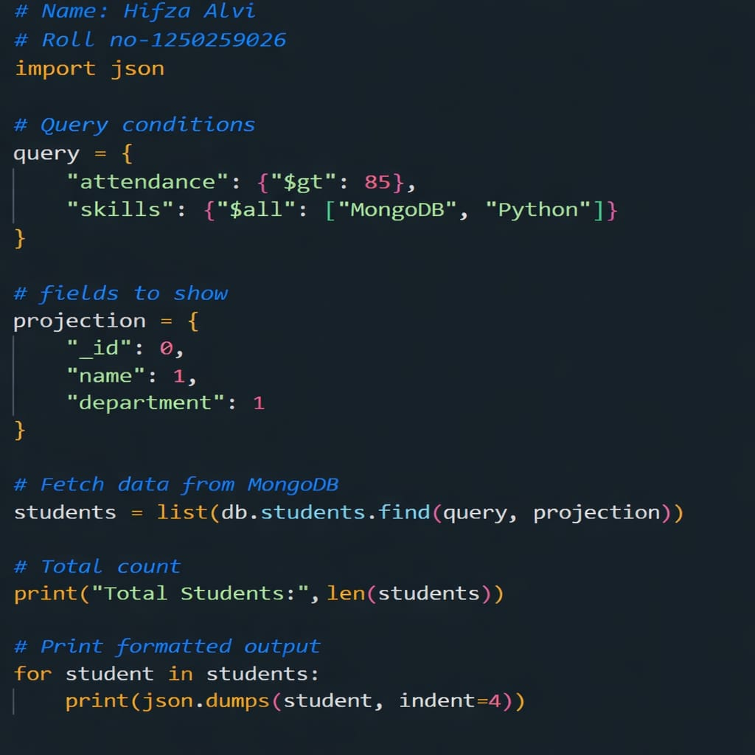

Output: Total Students: 0

Q2. Show all faculty who are teaching more than 2
courses. Display their names and the total number of courses they teach.

QUERY-
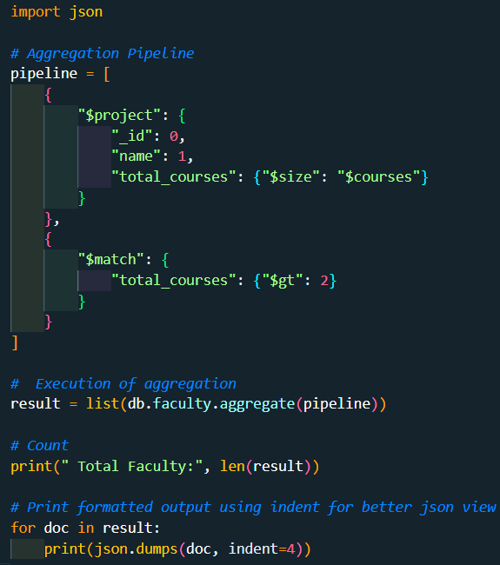

Output:
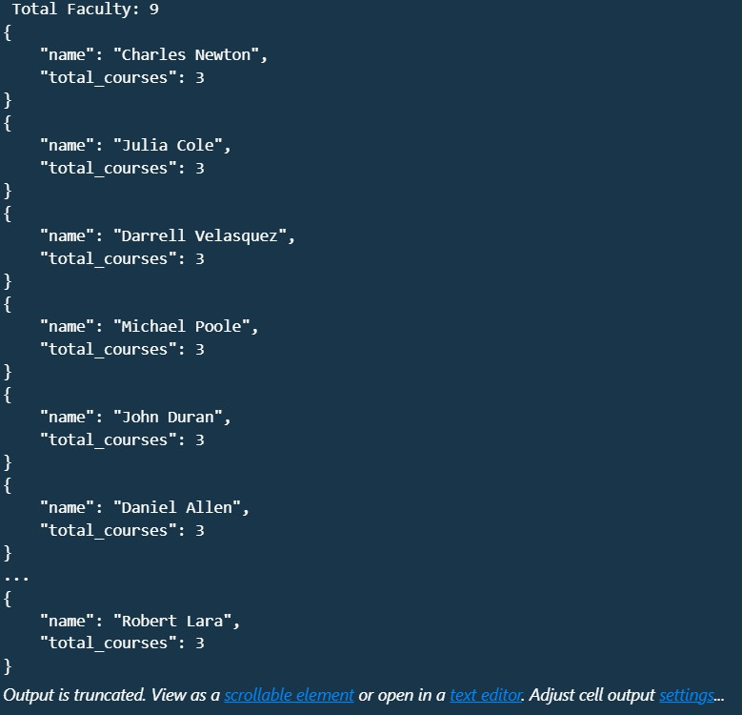

- Joins ($lookup) and Aggregations
Q3. Write a query to show each student’s name along with the course titles they are enrolled in (use
$lookup between enrolments, students, and courses).

QUERY-
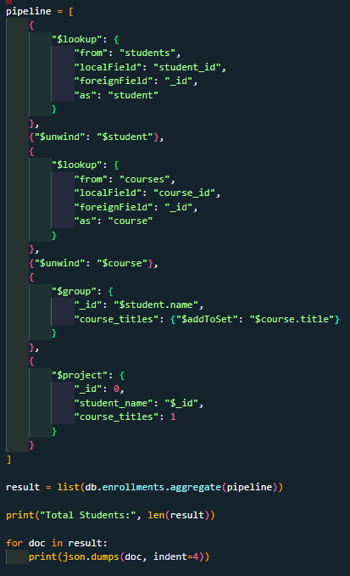

Output:
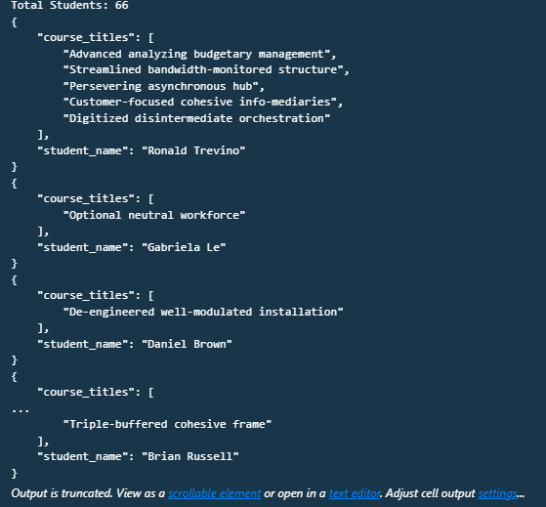

Q4. For each course, display the course title,
number of students enrolled, and average marks (use $group).

QUERY-
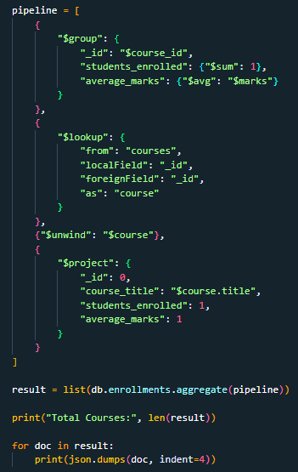

Output:
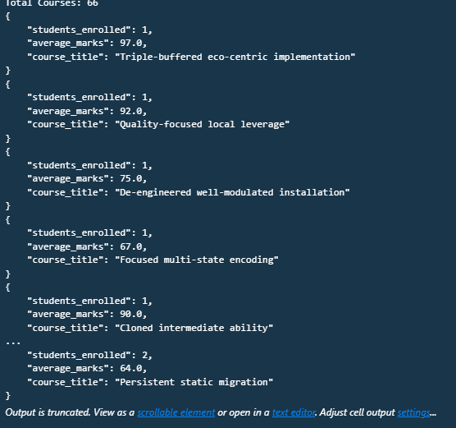

- Grouping, Sorting, and Limiting
Q5. Find the top 3 students with the highest average marks across all enrolled courses.

QUERY-
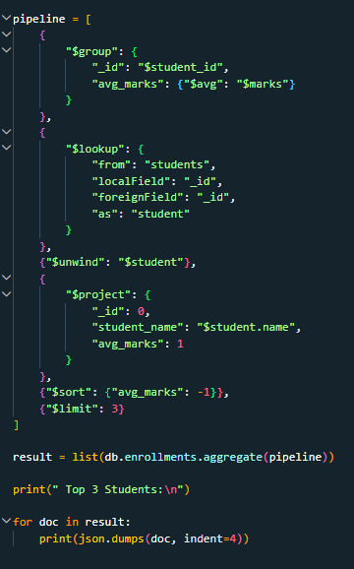

Output:
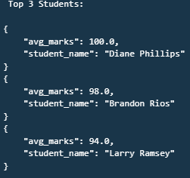

Q6. Count how many students are in each
department. Display the department with the highest number of students.

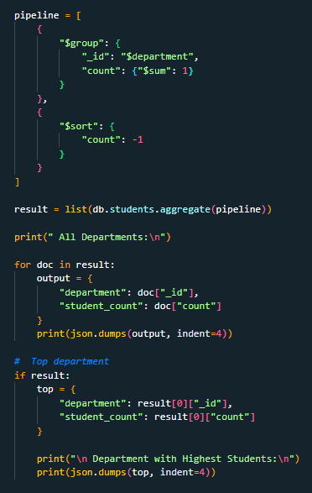
QUERY-

Output:
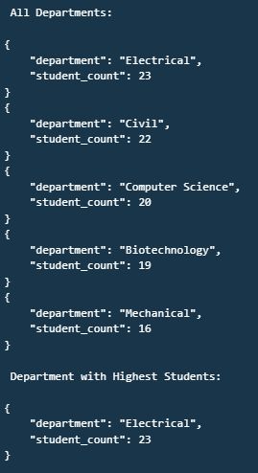

- Update, Upsert, and Delete
Q7. Update attendance to 100% for all students who won any "Hackathon".

QUERY-

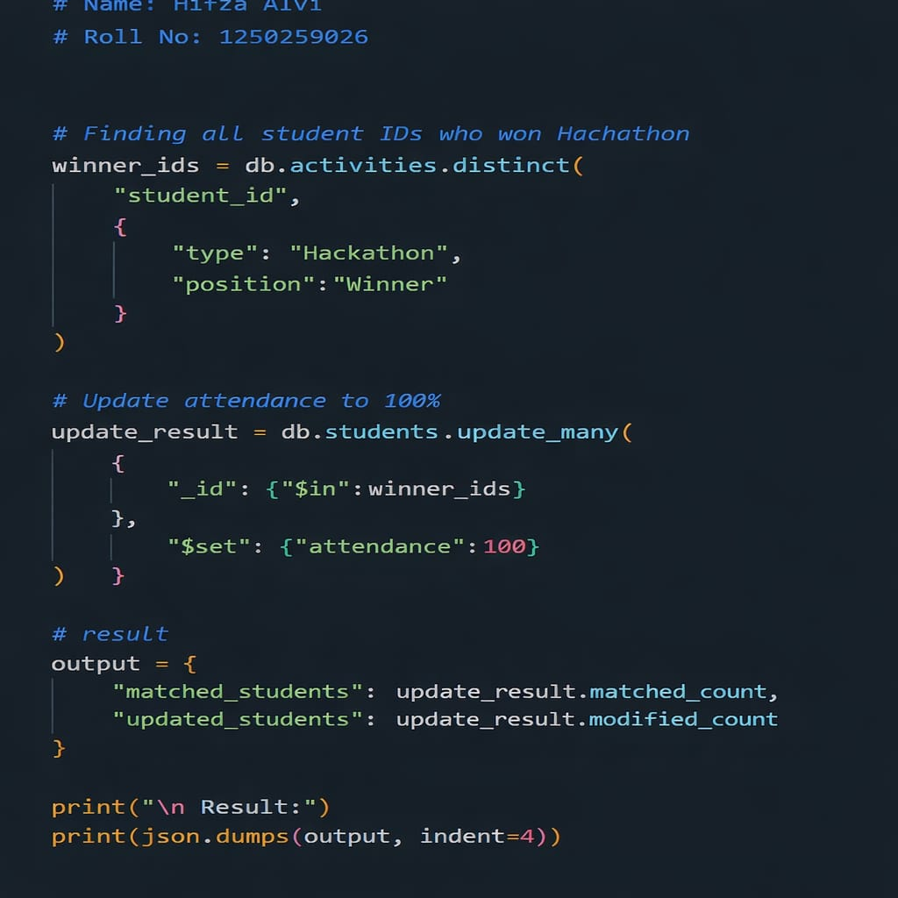
Output:
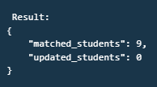

Q8. Delete all student activity records where the activity year is before 2022.

QUERY-
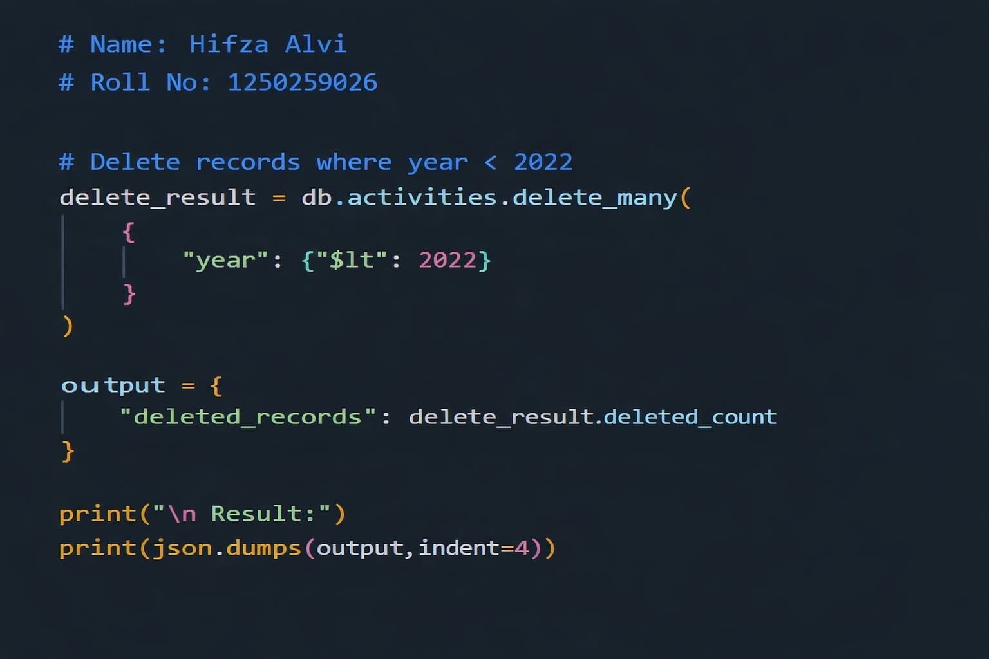

Output:
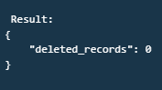
Q9. Upsert a course record for "Data Structures" with ID "C150" and credits 4—if it doesn’t exist, insert it; otherwise update its title to "Advanced Data Structures".

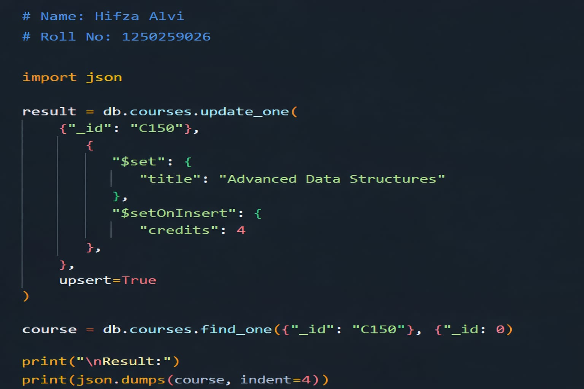QUERY-

Output:
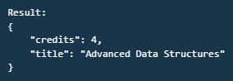

- Array & Operator Usage
Q10. Find all students who have "Python" as a skill but not "C++".

QUERY-

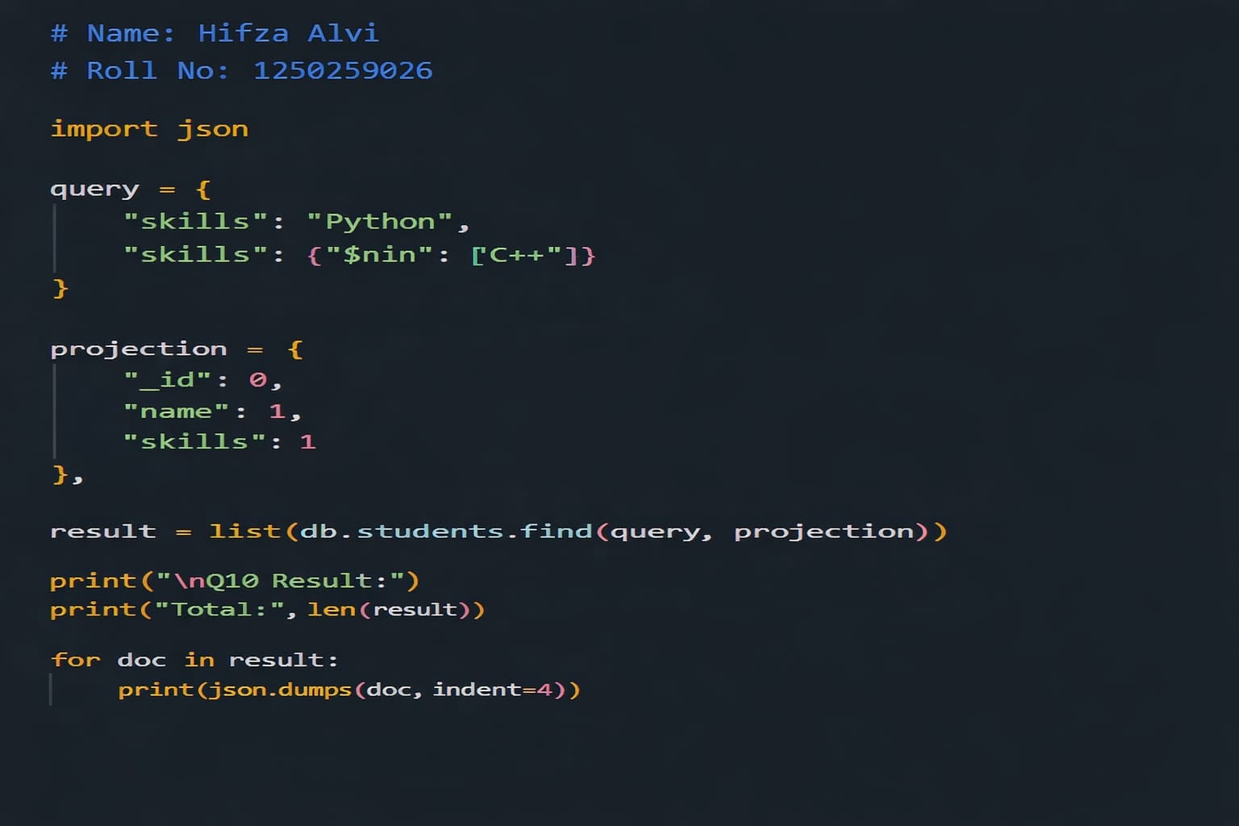
Output:
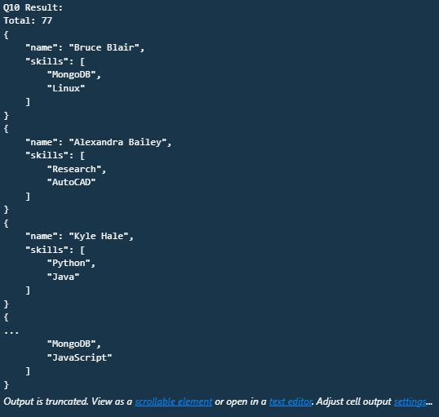

Q11. Return names of students who participated in
"Seminar" and "Hackathon" both. QUERY-

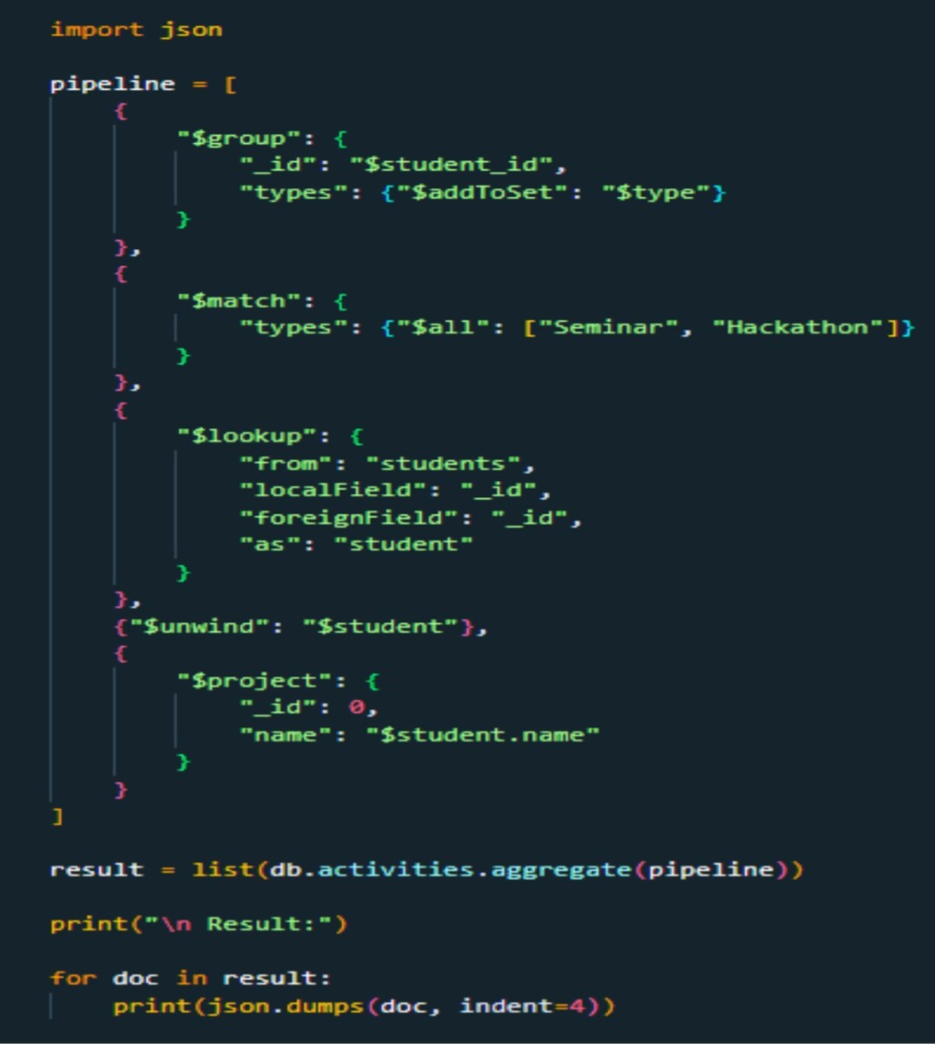
Output:
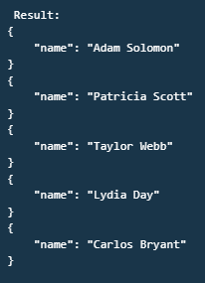

- Subdocuments and Nested Conditions
Q12. Find students who scored more than 80 in "Web Development" only if they belong to the "Computer Science" department.

QUERY-

Output: Result : Total:0

- Advanced Aggregation (Challenge Level)
Q13. For each faculty member, list the names of all students enrolled in their courses along with average marks per student per faculty.
QUERY-

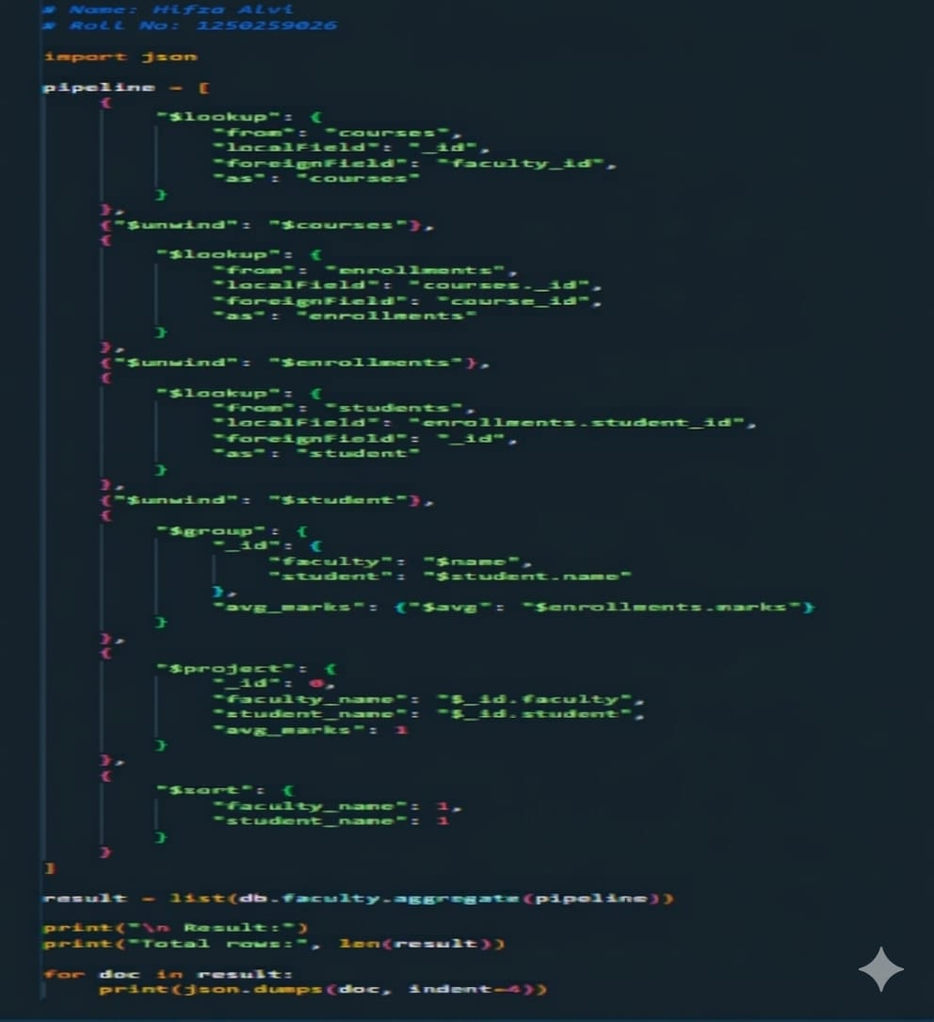
Output:
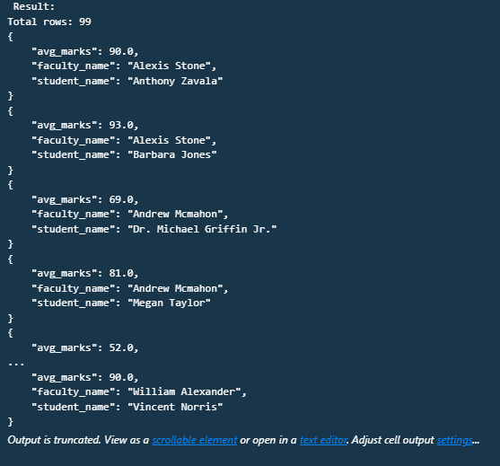

Q14. Show the most popular activity type (e.g.,
Hackathon, Seminar, etc.) by number of student participants.

QUERY-

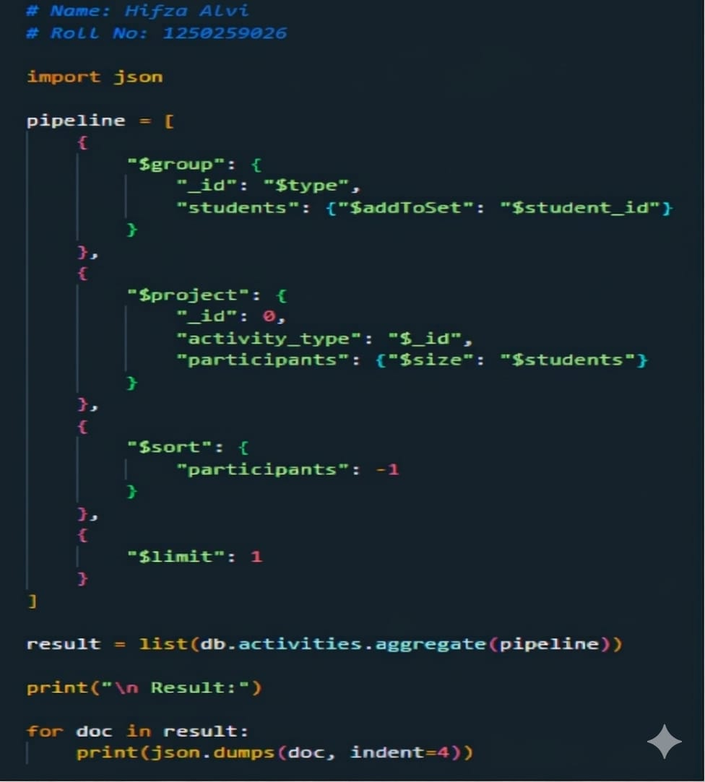
Output:
